2022-2023
South Dakota Department of Health
Office of Disease Prevention & Health Promotion
WORKWELL MENTAL HEALTH GRANT
Proposals due October 31st, 2022

PARTNERSHIPS THAT PROMOTE MENTALLY HEALTHY WORKSITES

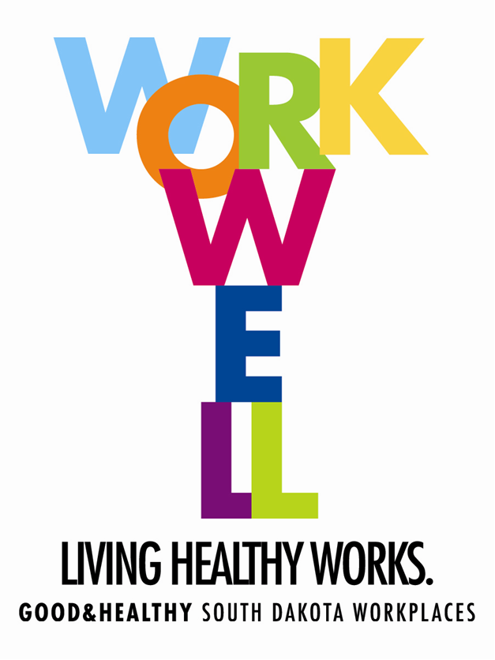

Overview
Nearly one in five US adults report living with a mental illness. In addition, 71 percent of adults report having at least one symptom of stress, anxiety, or feelings of being overwhelmed.
Worksites play an incredibly important role in their employees’ mental wellbeing. Investing in a mentally healthy workforce pays dividends by lowering medical costs, absenteeism, and disability costs, while increasing productivity, job satisfaction, and overall happiness. Eligible projects for the WorkWell Mental Health Grant will be awarded between $3,000-$6,000.

Eligibility Criteria
Any workplace starting a mental wellness program or expanding a current program is eligible. Programs often focus on mental wellness interventions at the individual, environmental, or organizational levels.

Mini-Grant Requirements
- A letter of support from leadership expressing the importance of employee mental health in your organization. Must be submitted with your application.
- Complete required intervention and any additional intervention(s) during the grant funding period (January 1, 2023-December 31, 2023).
- Awarded funds must be expended by May 31st, 2023.
- Submit an evaluation of selected intervention(s). Recipients will be required to report quarterly data on performance measures such as the following:
  - The number of individuals trained in mental health-related practices/activities that are consistent with the goals of the grant.
  - If participating in another intervention, the number of individuals who have attended classes or been trained in prevention and mental health promotion.
- Items below must be submitted to eweiss@bhssc.org no later than December 31, 2023.
a. Annual progress report.
b. Success story.

WorkWell Program Will:
- Provide resources, training, and support for implementing intervention(s).
- Provide funding to awarded worksites.
- One virtual or on-site worksite visit.

WorkWell Interventions
You will need a means of evaluating your chosen program intervention(s) to determine if it has had the intended impact within your worksite. The activities you choose should be considered the means to accomplish your goals, they are the small steps necessary to ensure that the change you are anticipating occurs. Anticipated changes should reflect an employee’s knowledge, attitudes, or behaviors. To do this, developing clear, time-oriented, and measurable activities will be necessary.

As worksites continue to work through the changes from the pandemic, we are open to new and innovative mental wellness ideas that promote sustainability.

WorkWell Mental Health Interventions
The interventions listed below can be used to strengthen your mental health initiative. However, you are also encouraged to seek other interventions not listed that would be most suitable for your workplace. Implementing the NAMI StigmaFree Pledge and/or The Hearts + Minds within your worksite is strongly encouraged.

Organizational Level Interventions

Pledging to NAMI’s StigmaFree Companies
Eight in ten workers say shame and stigma prevent them from seeking treatment for a mental health condition. NAMI’s StigmaFree Company initiative encourages Corporate Social Responsibility (CSR), or business practices that take responsibility for a company’s impact on employee’s wellbeing. This three-hour module training builds a strong foundation to support mental health wellbeing in the worksite. This initiative combines CSR with employee engagement activities available in a StigmaFree Company Toolkit.
Awarded organizations that pledge to be StigmaFree will be funded $3,000.

Additional NAMI hours of services (up to two sessions) can be provided at $500 a session.
Example of Additional Sessions: An organization with multiple work shifts or 100+ employees. Your worksite could potentially apply for up to $4,000 in NAMI services.

Other possible Interventions at this level include:
- Create policies that provide guidance to supervisors on mental health consultation and information and improve their skills to intervene or supervise an employee with mental health issues.
- Talk openly about mental health at staff meetings and encourage the use of Employee Assistance Programs or other mental health initiatives being offered.
- Have a dedicated mental health wellness champion to lead organizational efforts.
- Implement a crisis intervention and post-vention policy.
- Develop a partnership and a referral process with a local behavioral health facility.

NAMI’s Hearts+Minds is a wellness program designed to educate and empower you to better manage your health — mentally and physically. Two-thirds of deaths are caused by chronic diseases that can be prevented or better managed. And these diseases impact people with serious mental illness at alarming rates.
The best possible mental health recovery requires attention to all aspects of your health.
This 8 hr./module program will give you tools that can help you plan and achieve recovery goals and better overall health. These modules can be covered in an 8-hour class or one to two hours at a time. Awarded organizations of the NAMI SD Hearts+Minds program will be funded $5,000.
Topics covered:
- Medical Self-Advocacy
- Listening to Your Body- emotional and physical signals
- Managing Prescriptions- effective methods for managing the side effects of medication
- Self-Medicating
- Make Your Diet Work for YOU- gain a greater sense of control over how you feel
- Get Physical with Your Symptoms
- Peer Wellness- positive social connections
- Mental Health is Physical Health

Environmental Level Interventions

Provide presentations and training sessions for supervisors, leadership team, or management. For example, Mental Health First Aid trains the general public on how to identify, understand, and respond to signs of mental illness. QPR (Question, Persuade, Refer) teaches staff how to recognize the warning signs of a suicide crisis and how to question, persuade, and refer someone to help. See Appendix A to learn more about these training opportunities. To learn more about other training opportunities available, visit the South Dakota Suicide Prevention webpage.

Other possible Interventions at this level include:
- Provide mental health materials and messaging through various means (brochures, paycheck stuffers, intranet, listservs, posters, signs, or fact sheets).
- Encourage the use of mental health services provided by Employee Assistance Program (EAP), Helpline Center, 988, and other community resources.
- Offer stress reduction presentations on various topics, including conflict resolution, personal finance planning, managing multiple priorities, and self-care.

Individual Level Interventions

Provide employees with various mental health wellness classes that allow them to integrate simple exercises into their daily lives. These classes can be in-person, virtual, or through phone apps (CALM, Headspace, Mindfulness app). Mindfulness, meditation, resiliency, self-care, or yoga classes enhance employee engagement, build resilience, manage stress, boost productivity, and increase overall wellbeing, happiness, and job satisfaction.

Other possible interventions at this level include:
- Make mental health self-assessment tools available to all employees.
- Provide teach-ins with mental health professionals to raise awareness and knowledge.
- Offer confidential screenings for depression, anxiety, post-traumatic stress, and substance abuse.
- Encouraging in-person or online peer-to-peer engagement and support.

Funds WILL support:
Organizational Level
- StigmaFree Pledge Initiative.
- NAMI SD Hearts+Minds
- Stipend for Wellness Coordinator’s time.
Environmental Level
- Building renovations strictly for classes (yoga, meditation, mindfulness) or a stress-reduction room.
- Promotional & communication materials used on-site in break rooms etc.
Individual Level
- Offering onsite/virtual mental health-focused classes.
- Partnering with local businesses to help provide gift cards for relaxation and stress-reduction activities.

Funds will NOT support:
- Direct services (such as patient care, personal health services, etc.).
- Food or beverages at meetings/events/activities.

Funds CAN support: (up to 20% of the budget) promotional items for prizes or incentives such as How To Be Calm book, calming candle, adult coloring book, insulated tea mug and box of tea, Be Kind to Your Mind t-shirt.

Application Submission – Please submit your completed application by
5 p.m. on Monday, October 31, 2022
Submitted proposals must include the following:
A. Grant Application Cover (Pg.6)
B. Statement of Need (Pg.7)
C. WorkWell Intervention (Pg.8)
D. Budget Proposal (pg.9)
Submit via mail or email to:
Enid Weiss
Worksite Wellness Coordinator
Black Hills Special Services
PO Box 1840
Watertown, SD 57201
Phone: (605) 305-4522
Email: eweiss@bhssc.org

Section A.
COVER SHEET

Name of Workplace: ______________________________________________
Mailing Address: __________________________________________________
City: ______________________________________________________________
Zip Code: _________________________________________________________
Phone Number: ___________________________________________________
Contact Person: ___________________________________________________
Title: ______________________________________________________________
Email Address: ____________________________________________________
Number of Employees: ____________________________________________
Amount of grant request ($): _______________________________________

Section B.
STATEMENT OF NEED
Please complete the following:
- Describe your workplace’s industry and what services you provide.

- Why does your workplace need funding?

- Your current workplace:

  - Do you currently have a mental health program or initiative? Please describe.
  - If no, what are your plans to create a mental health program?
  - If yes, how is your current program/initiative funded?

- Please attach one letter of support from a member of your leadership team in Section E.

- Briefly describe how your organization will sustain funding for future activities and maintain a StigmaFree workplace.

WorkWell Mental Health Intervention(s): | Organizational Level | Environmental Level | Individual Level
WorkWell Mental Health Intervention(s): | - NAMI StigmaFree Pledge  - NAMI SD Hearts+Minds  - Create policies that provide mental health training to supervisors.  - Dedicated mental health wellness champion to lead organizational efforts.  - Implement a crisis intervention and post-vention policy.  - Develop referral process with a local behavioral health facility.  - Other | - Mental health communication and promotion materials.  - Encourage the use of mental health services provided by EAP, Helpline Center, 211 and other mental health community resources.  - Offer stress reduction presentations  - Stress-reduction/relaxation rooms.  - Other | - Mental health self-assessment tools.  - Mental health professional teach-ins.  - Confidential screenings.  - In-person or online peer-to-peer engagement and support.  - Other
Intervention(s):

List ALL Activities:
Timeline: | January 1, 2023- December 31, 2023
Communication Strategies:
(email, posters, staff meetings, newsletters, brochures)
Section C.
WORKPLAN
Section D.
BUDGET

Provide an itemized budget proposal in the table below. Awardees may revise or adjust the budget after receiving the award; however, DOH must approve any budget revisions before items can be purchased. DOH will not reimburse any purchases made prior to budget approval. Awarded worksites choosing to implement the NAMI StigmaFree Pledge and/or Hearts + Minds will receive $3,000+ to support this training.

INTERVENTION | AMOUNT
TOTAL AMOUNT | $

APPENDIX A
South Dakota Suicide Prevention Trainings
The following trainings are related to mental health and available in South Dakota. Worksites can request trainings on the South Dakota Suicide Prevention (SDSP) website for their employees. Training costs depend on number of individuals being trained and how many trainers conducting the training. Worksites will work with SDSP to determine training needs and costs.

Training | Description | Availability | Cost
Mental Health First Aid (MHFA) | Trains the general public to identify, understand, and respond to signs of mental illness. | 8-hour course, available in-person and virtually. | $1,500-$2,000
Youth Mental Health First Aid | Reviews risk factors and warning signs of mental health problems in adolescents ages 12-18. | 8-hour course, available in-person and virtually. | $800-$1,600
Applied Suicide Intervention Skills Training (ASIST) | Helps participants feel more comfortable, confident, and competent in helping prevent the immediate risk of suicide. | 2-day course, available in-person only. | $3,000-$4,700
Question, Persuade, Refer (QPR) | Learn how to recognize warning signs of a crisis and how to question, persuade, and refer someone to help | 1-2-hour training, available virtually only. | $300-$500

